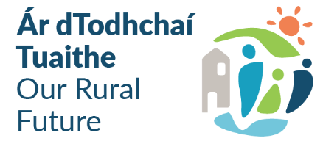
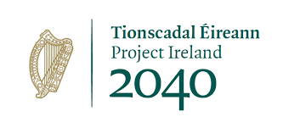
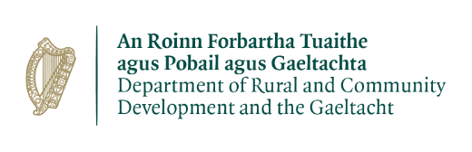

OUTDOOR RECREATION INFRASTRUCTURE SCHEME 2026/2027
Project Development Measure - Application Form
Local Authority/Local Development Company/State Body Information:
Project Name:
(This will be used for the Press Release, if approved) 5-10 words max.
Lead Organisation:
Contact Person:
Address:
Email:
Telephone No.:

Local Community Group Information
Project Name:
Position:
Contact Person:
Email:
Telephone No.:
List all other stakeholders involved in this application:

Project Information
Indicative prioritisation given to this project LA 1 – 4 + 2, LDC 1 - 3
(1-6 subject to standard allocation of 4 plus an island location or an equestrian application)
Please provide a clear and concise description of the proposed project:
This will be used for public announcements, if approved. Max. 30 words.
Project Type: New amenity or maintenance/upgrade of an existing amenity:
Is there any other application pending for this project?
If so please outline:
Location of proposed project: Include nearest town/village:
Please provide the Eircode and/or XY (ITM format) Coordinates of the project: XY coordinates should be captured in Irish Transverse Mercator (ITM) formats. Coordinates can be converted to ITM format here: Active GNSS Station Data. This data will be used to geo-map all successful projects |  |  | EIRCODE  XY (ITM)
  E |  |  |  |  |  |  |  | N
Please provide a map (if applicable) showing the location of the project and the works that are to be completed:
Exact length of proposed works to be funded under this application (if applicable):
Identify start and end point on map
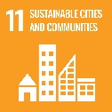
Outline the steps taken to ensure that the proposed locations and projects have been identified in consultation with relevant communities and in particular in consultation with the local residents, local Community Response Fora, LCDC, LDCs and any other stakeholders.
List events that facilitated this consultation e.g. Town-Hall meetings, advertisement, local media, social media, consultation with elected representatives, PPN’s, resident’s associations etc.
Has this application been discussed with the Outdoor Recreation Committee or, where not in place, the project team for county outdoor recreation plan?
If so, please outline:
Does this project align with the actions in the County Outdoor Recreation Plan?
If yes, please outline:
How does this project align with ORIS?
Has this project been discussed with Biodiversity and/or Heritage Officer at County level:
If so please outline:
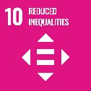
Outline how the project will support an inclusive approach or enhance opportunities for people with disabilities and is aligned with universal design and accessibility principles:
Are these works part of a larger project?
If yes, what are the objectives of the larger project, and give details of funding approved, applied for and planned for the other phases.

Include details of previous funding applied for or granted under ORIS and any other applicable funding (RRDF, Sports Capital etc.)

Please provide a synopsis of the proposal, detailing the intervention envisaged and the works proposed. Include a summary of the project that will be developed as a result of the completion of the Project Development proposal:

Outline how the proposed final project supports outdoor recreation:

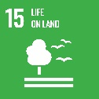
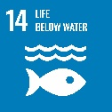
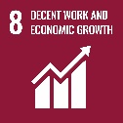

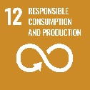

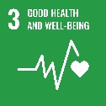

How will the final project support tourism in the local area:

Outline how the proposed final project is strategic in nature:

Detailed Costings for Proposed Project:

Please provide detailed breakdown of all elements of the proposed works:
Project Elements*  (provide details of each element) | Cost (inc. VAT)
 | €
 | €
 | €
 | €
 | €
 | €
 | €
 | €
Local authority non-administrative costs (if applicable)
1. | €
2. | €
3. | €
4. | €
Total Project Cost (sum of project elements costs) | €
Grant Aid amount sought  (Max of 90% of total project costs) | €
Match Funding: (Min 10% of total cost) | €
Match Funding supplied by (LA/LDC/Community/Philanthropic): Please State who is providing match funding.

*Failure to provide adequate detail and costings will result in the project receiving lower marks

Timelines:
Projects funded under the Project Development Measure should be completed within 18 months of approval. It is expected that these projects will be approved in Q1 2027

Please provide an indicative time frame for completion of the project:

Indicative time frame: (Weeks/Months)

Use of Data
The information on this Application Form will be used by the Department of Rural, Community Development and the Gaeltacht for the purposes of processing the application. Further information may be sought by the Department to clarify aspects of the project proposal. The application form will be shared with Fáilte Ireland and Sport Ireland for assessment purposes. The Department may draw on broader, more specialist expertise where required, and such information as considered necessary to complete an assessment of your application may be shared with those experts

The Applicant and the Department are subject to the data protection and privacy laws of Ireland and the EU, in particular the Data Protection Act 2018 and Regulation (EU) 2016/679, known as the EU General Data Protection Regulation (“GDPR”). Any personal information which you provide as part of the application process will be obtained and processed in compliance with Data Protection legislation.
The Department retains the right to disclose for the purposes of a request under the Freedom of Information Act 2014 or otherwise, in connection with the funded project(s) –
- any information supplied by the Applicant to the Department,
- any relevant data gathered by the Department in administering grant aid to the project, except where the information is considered to be personal or commercially sensitive.

Declaration by Lead Applicant
This declaration must be signed by an officer authorised at a senior level within the lead applicant organisation i.e. at least Director of Services level in a local authority, Chief Executive Officer in a local development company or Director in a State body.

I confirm that I have read and understood this document and declare that the particulars supplied in this application are true and correct and that –
- This project is eligible under the ORIS criteria and Embracing Ireland’s Outdoors.
- The costings are accurate and reasonable.
- Match funding is available for the project.
- The project will comply with Public Procurement Guidelines.
- The project conforms to the LECP and other local or regional plans.
- No funding has been allocated for the same works from any other sources.
- This project aligns with the County Outdoor Recreation Plan

Proof of the above is not required at the time of application but must be available to the Department or its agents on request.

I acknowledge the information regarding the use of data set out above and give consent to the Department of Rural and Community Development and the Gaeltacht for the sharing of all information, personal or otherwise, contained in this application and any attachments accompanying it, in accordance with the uses of the data and information provided above.

Signed on behalf of __________________________ (Lead Applicant Organisation

Director of Services / CEO signature _______________________________

Name in Block Capitals___________________________Date_______________

